|  |
| --- |
| How to Edit Sessions in CYSH |

1. Go to CYSH via your [Okta Homepage](https://cityyear.okta.com/app/UserHome) (cityyear.okta.com)

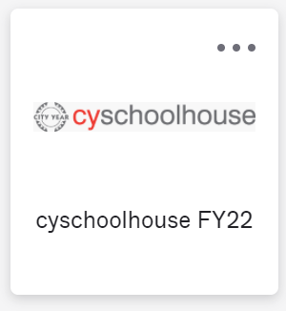

1. Select the section you want to edit time for

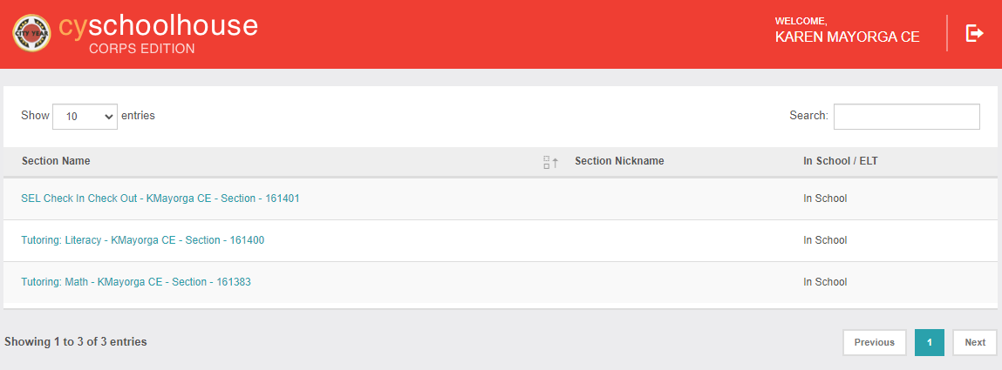

1. Click on History at the top right-hand corner

1. Find the session by using the availabe filters on the page (student name, date of session, etc)

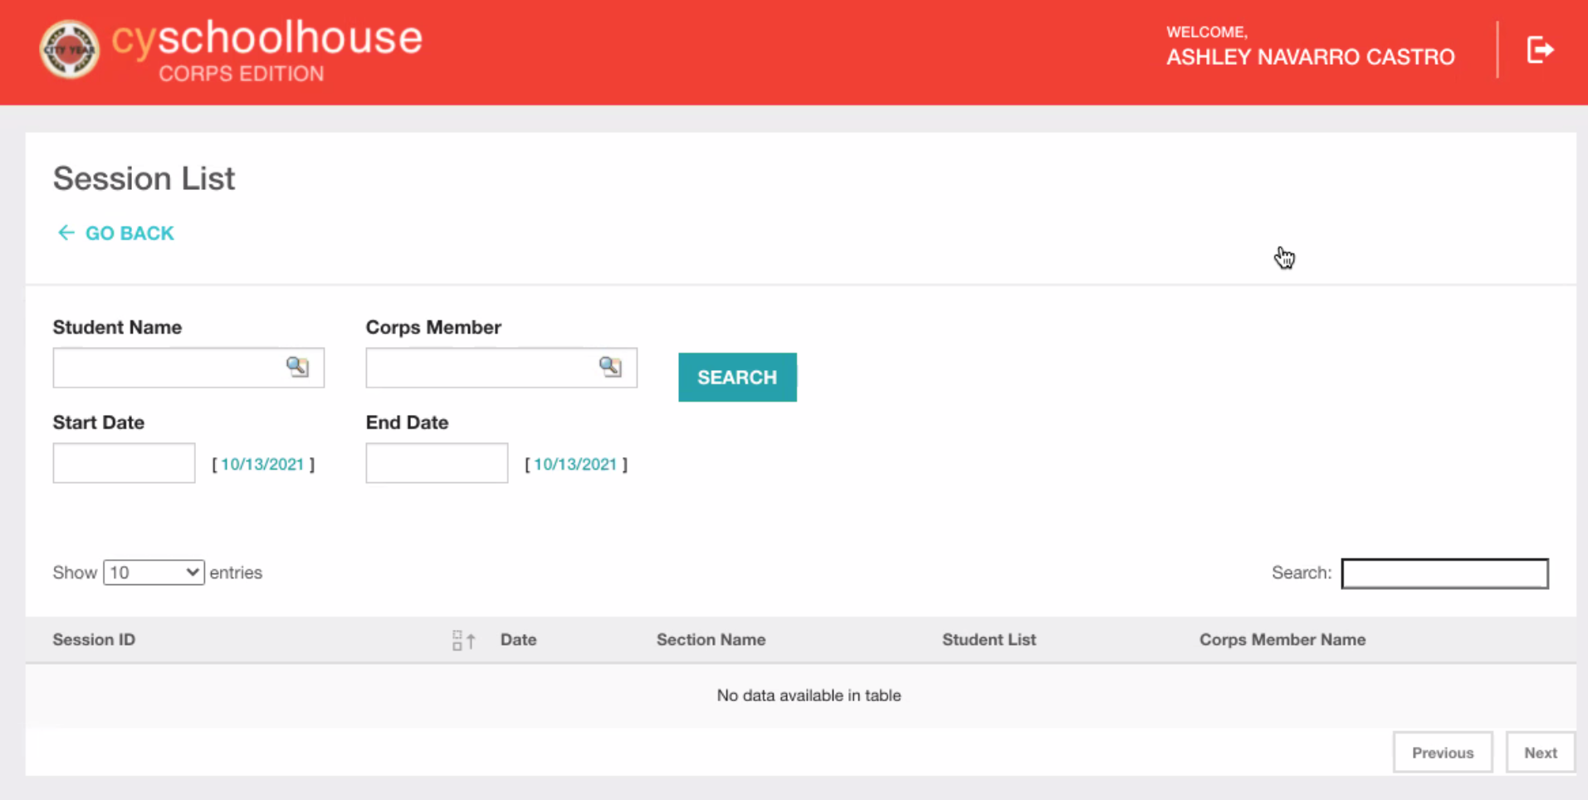

1. Edit the session date, drop-downs, number of minutes spent on the session, OR the students in the session. Once you’ve made the desired updates, click submit!

